PEOPLES TRAINING AND RESEARCH CENTRE
43, Srinathdham Duplex, Dinesh Mill- Urmi Road, VADODARA-390007 Ph: 2345576

Report for the year 2015-16

Relief paid to the silicosis victim families:

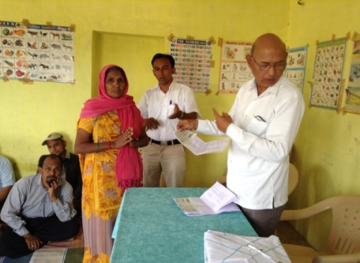
Last year Government of Gujarat resolved to pay relief amount of Rs.1 lakh to the families of diseased Agate workers. In response 75 had made their claims. On 5 June, 13 families were handed over cheques by Asst. Labor Commissioner (Rural) at a function organized at PTRC Office. This was an important mile stone in long struggle for justice to the Silicosis victims. Later, during the year 59 families received the relief.

Spot inquiry by National Human Rights Commission:

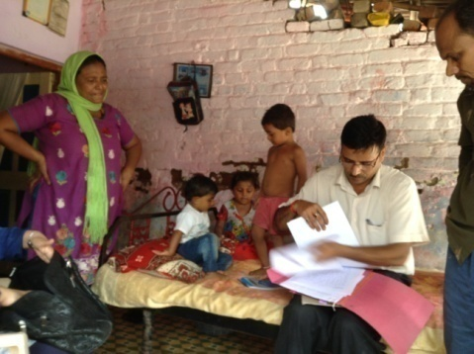
NHRC is paying attention to the problem of Silicosis since 2006. Same year PIL was filed in Supreme Court of India by Delhi based NGO PRASAR. Commission joined the PIL as respondent. In 2009 Honorable Court passed interim order in this matter and instructed NHRC to go-ahead with the State Governments to pay compensation/relief to the confirmed cases of death and treatment and rehabilitation for the workers living with Silicosis. Since 2010 we started filing formal complaints with the Commission in this regard. We have filed 10 complaints for Khambhat and few more for Jambusar, Dahod and Chhotaudepur. NHRC decided to send its team for spot inquiry. From 23-26 June the Committee headed by IPS Officer visited Khambhat and held meetings with relevant Government departments, traders and victims. They recorded statements of the victim families. Later, the Committee submitted its report to the Commission. The Commission has sought responses from Government of Gujarat and complainant PTRC. This was again another important mile stone.

Day Care center:

We started Day care center on 1 April, 2006 for 20 children of 5 year or less. Our field staff observed that the women agate polisher carry their children to work place and work while the child is in their lap. During the polishing work fine silica dust would keep flying and as it would be inhaled by the worker, so the child and affect their adversely. To prevent silica exposure to the children we started this day care center and we received good response. In last 9 years 113 children have been benefitted. We serve freshly cooked food in our kitchen. A teacher would take care of them, play with them and also teach them, sing songs. Each month end meeting with parents is organized.

Work with Silicosis victims:

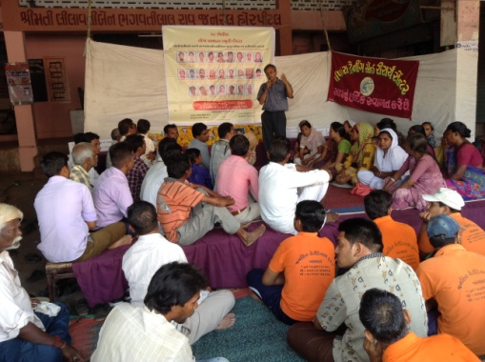
We observe 28 April each year as International Workers Memorial Day. We pay homage to the workers diseased during the year. Each year we put tent near Shakarpur Gram Panchayat. Now the victims are more confident. They thought that now we should organize program in City center of Khambhat town. Tent and stage was put up under Municipal Shopping Centre at Gawara Tower. Highest numbers of deaths were registered during this year. Huge banner having pictures of all 25 diseased workers was put up. Large numbers of workers, family members of victims, representatives of different voluntary organizations, elected councilors and other citizens attended the event.

Agate workers are not issues identity cards so we decided to issue Identity cards. We decided to issue yellow color cards to silicosis victims and white color cards to the Agate workers.

Diagnosis and Treatment:

In collaboration with Sri Krishna Hospital, Karamsad and Cardiac Care Centre, we initiated weekly clinic for screening of silica exposed population in Khambhat and surrounding area. Each Wednesday experts of Chest & TB department visit the clinic during 10.30 am to 1 pm. After taking occupational history, physician may refer the patient for X-ray. Patients can avail facility of free X-ray from Cardiac Care centre. Based on X-ray, occupational history and complaints, final diagnosis would be done and if found positive for silicosis, certificate to the effect would be issued. PTRC Field staff keeps moving among exposed population to indentify and encourage them to visit the clinic for screening. 1273 persons were screened during 2007 to 31-03-15 out of which 229 were found positive. During the year 221 new patients visited clinic, 184 X-rays were submitted to us and 7 were confirmed positive for silicosis.

To get more patients we invited active and interested citizens to join us as volunteers. They may contact agate workers in their area to introduce PTRC and its activities, educate about silicosis and explain importance of screening. During the year 11 volunteers joined us. During the year they encouraged 164 workers to visit the clinic. They submitted 123 X-rays.

If we look at the data of new patients visiting clinic for last 5 years, we observe that highest numbers visited in 2015.

Year (Calendar) | Number of new patients | X-ray submitted | Silicosis diagnosed
2011 | 131 | 114 | 56
2012 | 217 | 156 | 21
2013 | 107 | 078 | 17
2014 | 203 | 136 | 15
2015 | 223 | 175 | 153
Total | 881 | 659 | 262

Dr. Muralidhar V. is an old friend. He was to visit Ahmadabad for personal work. We contacted him and requested him to help in diagnosis of silicosis. He consented. We presented before him our x-rays out of which he certified 138 as positive.

Our clinic is situated in Shakarpur village which is far away for the workers in some areas in Khambhat city. As a result they would hesitate in walking down that distance. Since long we were looking for a place in the city to open alternate clinic. During the year we succeeded. In Tin Limdi area we could find a small rented house for clinic. It was white washed and we bought required basic furniture and opened the clinic from 10 June. Now, clinic operates each alternate Wednesday at this place.

On 7 August we visited State empowered expert committee for confirming diagnosis with health department officials and presented x-rays.

Rehabilitation of silicosis victims:

In earlier year we had trained 9 women in operating Charkha (spinning wheel) and later 4 among them were given Charkha. In our office we placed one Charkha for demonstration. We then requested two of our staff looking after day care center to operate Charkha in their free time. Whatever they may earn may be distributed among them after giving fare share to the organization.

Technological Experiments to prevent silicosis:

We could not get satisfactory results in the experiments that we had started to reduce silica dust levels. Machine was extracting dust but we were not able to collect it safely. As per advice by the expert we prepared three different proto types but more experiments were required.

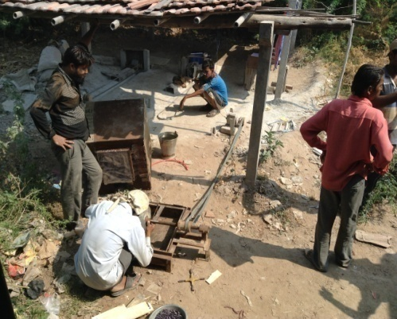
In the meanwhile Toronto University applied for grant for a project to reduce dust levels in agate processing under Grand Challenges program by Government of Canada. Application got sanctioned. University of Toronto invited Canadian Charity "Work place health without border" and PTRC to join hands in this project. Three Canadian experts - Paul Bozek, Om Malik and Merian Blevetsky visited Khambhat during 28 September to 18 October and carried out experiments. This was their third and last visit during the project. During this visit they bought exhaust from Baroda but dust collection still remained problem. These experiments will continue.

Deaths due to silicosis:

During 1 April, 2015 to 31 March, 2016 16 silicosis victims (15 Male and one female) died. The number was 19 and 26 respectively in two earlier years.

Women empowerment in Khambhat:

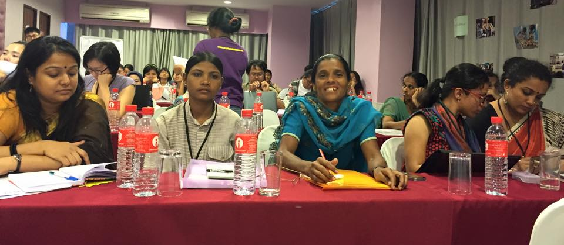
We had reported our efforts for women empowerment during 2014-15. We continued the work. Selected women were imparted training and as part of the training they had visited some organizations. SEWA Bank was one of the organizations they had visited. They were highly impressed with the Bank and they made demand with us to join them with the Bank. We contacted Bank and invited them to Khambhat. SEWA Bank officials visited Khambhat on 19 June, 2015 and explained how women can join them. 48 women formed 4 groups viz. Sidhharth nagar group (13 members), Khwaja Garib Nawaz group (15 members), Bar Bhai ni khadki group (11 members) and Pir Ansari Bachat Mandal (10 members). All the members save Rs.100 per month. Bank disbursed them loan of Rs.3 lakh.

On 20 August women workers came together and after serious deliberations decided to form Khambhat Shramjivi Mahila Sangathan. Tahera Diwan was selected to be President, Mahefuja Syed as Secretary and Fuliben Parmar as Finance Secretary. 6 others accepted to be members of executive committee. Rs.20 per month or Rs.200 per year was fixed as subscription rates. By March end 80 women paid subscription. They decided to visit PDS officer to represent issuance of Antyoday Card. As a result of these efforts Madhuben Parmar and Shayraben Pathan were issued the cards. Next meeting met on 22 October. Some members represented that women hesitate in paying subscription and it was suggested to review the subscription standards. Matter was discussed and subscription was reduced from Rs.20/- per month to Rs.10/- per month and annual Rs.100/-.. When they were asked on the benefits of joining the organization they said that our fear is coming down and we are gaining more confidence. Asia Monitor Resource Centre organized meeting on women workers rights at Bangkok from 26-28 October and we got invite. Sangathan decided to send their President Tahera Diwan for the meeting. She attended the meeting which was her maiden foreign trip. She presented her report in the meeting convened on 31 October. On 21 November this group visited Patdi town to meet with members of SWATI organization. SWATI has organized women who struggled collectively for drinking water, state transport bus service and other problems and have largely succeeded. They have formed savings groups. 4500 women form 45 villages have saved Rs.95 lakh and have disbursed loans worth Rs.52 lakh. Women have bought even tractors from this saving.

On 25 August Renu Khanna of SAHAJ organization visited Khambhat and met with the members. 42 members attended this meeting.

We then decided to impart training to another group. We recruited women for the training and had meeting with them on 2 October which was attended by 20 participants. Volunteers of AWAG gave them three day training from 22-24 November. On 6 December Harinesh Pandya gave them training on Right to Information Act. RTI Activist from Tarapur Bhanuben also shared her experiences. On 31 December they visited Jagrut Mahila Sangathan in Anand. They run hostel for the women who have been thrown out of the house following dispute with husband and in-laws. On 3 January CHETNA gave them training on health which was attended by 25 members. In this training they were given exposure to malnutrition, hemoglobin, menstrual cycle etc. On 27 February Jagdish Patel gave them training on leadership development in which he talked about democratic set up. It was attended by 13 members.

Rahima Diwan, Tahera Diwan and Fuliben Parmar attended meeting of Food Security campaign at Ahmadabad on 29 February. On 8 March one group attended program organized by AWAG in Ahmadabad and another went to Anand to attend program organized by Jagrut Mahila Sangathan.
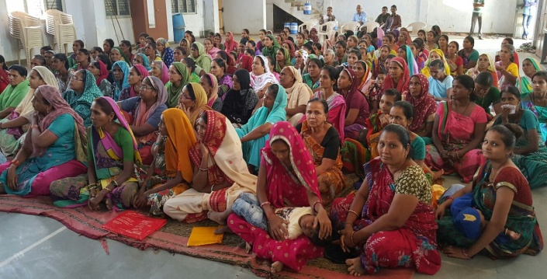
On 10 March in collaboration with AWAG, CHETNA and SAMARTH we organized program as part of One Billion Rising, an international movement to prevent violence against women at Khambhat. Large numbers of women attended it. On 22 March we invited meeting of kite workers. Over 100 women workers attended the meeting. They said that they earn Rs.30/- at the end of 6-7 hours work. It was decided to organize another meeting with them.

Work for silicosis in Jambusar area:

Our field staff had visited villages Gulal, Degam, Thanava etc. in Jambusar area in April, 2015 to meet silicosis victim families. He again visited them in June. He helped them claim relief of Rs.1 lakh to these families by filling up forms and helping with documents required. He also visited Rural Labor Officer in Bharuch.

Work with Jute workers:
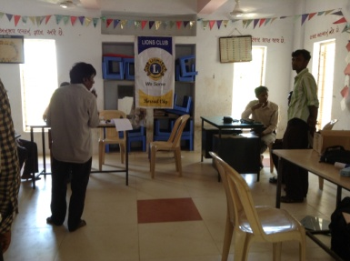
We organized medical camp for jute bag recycling workers at Tekariyapura near Borsad on 24-05-15. Through our friend Dhiru Mistry we could get support of Lions Club, Borsad. Dr. Atul Gupta and Dr.Ajay Gupta gave their services for the camp.

Silicosis in Khadgodhra:
Narmada project outs tees from Madhya Pradesh have been rehabilitated in village called Khadgodhra near Balasinor. Some among them work in quartz crushing units in Khadgodhra. We had established rapport in this area last year, details of which is given in annual report for the last year. Sanjay Ghaghretiya, our field staff visited the area again in May and July. He visited victims and local hospitals to get the X-rays done for these workers. On 4 August X-ray camp was organized where 8 workers got the X-rays done.

Felicitation:

On January, 3, Jagdish Patel was felicitated with Navkala Sewa Samarpan Award. Sri Ramesh Patel "Premormi", founder of Navkala felicitated people from different walks of life in memory of his late parents at this occasion.

Visitors:

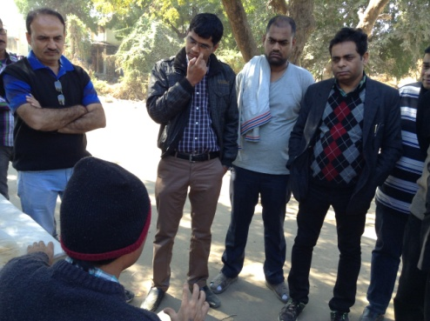
- Students of Industrial Hygiene, Vallabh Vidyanagar visited Khambhat on 24 July.
- Students of Medical College, Karamsad visited Khambhat on 13 August. Jagdish Patel talked with them on Occupational Health.
- Renu Khanna visited Khambhat with her colleague Mahima on 25 August.

- On 24 September, representation of voluntary organizations of Vietnam and Cambodia visited Khambhat.
- Students of Indian Inst. of Pubic Health visited Khambhat under leadership of Dr.Shyam Pingle on 13 February.
- Social Workers from Pune, Pramod Mujumdar visited Khambhat on 13 March.
- Harish Patel, social worker from Bareli visited Khambhat on 22 March. Bareli is known for the Kite and Manja. Khambhat also is big center of Kite manufacture. To connect both these centers we organized meeting with kite women workers with Harish.

Inquiry/Research/Visit:

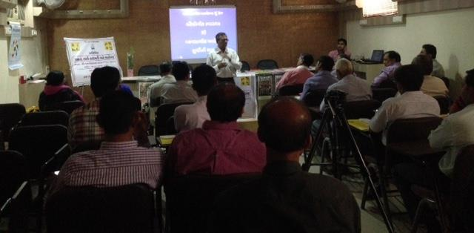
- Jagdish Patel joined fact finding team visiting Jamnagar on 13-14 December. Team prepared its report on the large scale riots by Reliance workers on 17 September, 2015.
- On 17 March we visited Hospital in Kim and visited Dr. Suresh Chhabra and Uttambhai Parmar to discuss develop system for diagnosis of occupational diseases.

Lecture/Training/Exhibition/Stall:

- We delivered lecture on Occupational Health at annual meeting of Theis Steel Employees Union at Navsari. At the end of the lecture workers bought literature and paid subscription on SALAMATI.
- Kutchh-Saurashtra Productivity Council, Rajkot, SEVA Foundation and Jeevan Mangalya Trust came together to organize day long workshop by Jagdish Patel on Occ.Health.
- On 22 May we attended awareness program organized by ESIC and imparted information on Occupational Diseases.
- On 26 May we spoke on hazards faced by children of migrant workers at Seminar organized by PRATIKAR trust at Chhotaudepur.
- On 1 June we were given opportunity to speak at meeting of officers of Labor department at Gandhinagar. I suggested the officers to work on occupational diseases like noise induced deafness and silicosis.
- On 19 September we were invited by Voluntary Health Association to organize session on Occupational Health at their meeting.
- On October 1, attended meeting panel of judges to see the documentaries made by students of Industrial Hygiene branch of IStar College, Vidyanagar. They made the films as part of competition. Panel of judges included Jagdish Patel, Paul Bozek and Dhiru Mistry.
- Jagdish Patel delivered two lectures on 20 October at Indian Inst. of Public Health, Ahmadabad.
- In collaboration with Asia Monitor Resource Centre we organized training for the members of Union of Garden Reach Ship Building Co, Kolkata on 8-9 January.
- On 25 January delivered lecture before students of School of Health System Studies at Tata Institute of Social Science, Mumbai on 25 January.
- Delivered lecture at Social Work Faculty in Vidyanagar on 3 February.

Meetings:

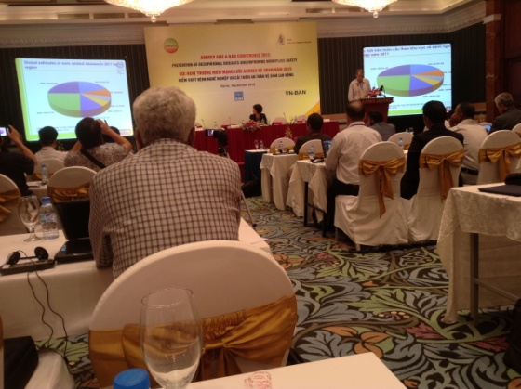
- Attended meeting organized by SHAISHAV on 5 April at Bhavnagar.
- Organized Press Conference at Ahmadabad on 2 May to demand inclusion of Chrysotile asbestos in PIC list of Rotterdam Convention. It was attended by Dr.Jagdish Parikh, Raghunath Manvar of OHSA, Vipul Pandya of Bandhkam Mazdur Sangathan and few asbestos victims. They gave information to the journalists.
- Jagdish Patel attended ANROEV conference at Hanoi on 3-7 September. He organized workshop on occupational lung diseases.
- We visited Dr.Paresh Dave, Director, Health services, Government of Gujarat to represent Khambhat claims.
- With Paul Bozek of Toronto University we visited Gems and Jewelry Export Promotion Council, Surat to discuss project on common shed for agate workers in Khambhat.
- Attended meeting organized by Global Green Grant Funds at Ranchi on 24-25 October for the groups working on Silicosis.
- Attended deliberations on fiscal policy recommendation report prepared by Public Health Foundation of India at Manesar on 27-28 October.
- Screened documentary film "Living Stones" before group of agate workers at Khambhat on 17 January. The documentary was made in 1980-82 on the agate workers of Khambhat by Durdarshan. It was made by Joseph Valakuzhi who after 30 years wanted to make sequel of the documentary. He remained present at this event and discussed with the viewers, who among those interviewed in this documentary are still alive.
- We attended inauguration ceremony of new building of Balashram established by Gram Seva Trust, Kharel on 20 January. Prakash Amte and his wife inaugurated the building. It was great opportunity to hear his experiences.

Work on ESI:

- ESIC demanded documents of late Fakira Veersing which we submitted on 15 March.
- Attended Suvidha Samagam on 12 August and represented complaints of Premlal Sharma and 8 others. Sometime back Prime Minister had announced ESI-2 Scheme under which bed sheets of ESI hospitals were to be of different colors in a week so that one can know if bed sheet has been changed daily. We asked if this will be enforced in ESI Hospital, Vadodara. We were replied that since Vadodara ESI hospital is run by ESI Scheme, the scheme do not apply to it. It is applicable only to the hospitals run by ESI Corporation. In Gujarat there are only two hospitals run by ESIC.
- We filed written complaint to Asst. Director, ESIS about liaison office of ESIS in SSG Hospital on 16 November. On 21 January we received reply saying instructions have been passed on to the liaison office to maintain register.
- We issued press note demanding secondary medical care at Waghodiya GIDC by ESI. On 5 December a worker died in that area since ESI services was not available.
- We represented for conveyance allowance to be paid to the patients referred by ESI dispensaries in the city which are away from ESI hospital 8 Km or more. We were replied on 13-01-16 that our demand is accepted.
- On 22-12-15 we filed complaint regarding examination by Medical Referee. ESIC do not pay benefits till patient is examined by the Referee. Referee is not appointed for a long time till then insured persons have to wait.

Living example of the problems faced by the insured persons under ESI Act:

Mukesh Yadav, working for Munjal auto in Waghodiya industrial area met with accident at work on 30 March, 2015 in which two fingers of his left hand got crushed. Accident took place at 9.50 PM. He was immediately taken to ESI Hospital, Gotri by vehicle provided by the company. They reached Gorti by 10.50 PM. They gave him treatment but refused to admit him as indoor patient. Instead ESI Hospital referred him to SSG Hospital. At SSG Hospital he was asked to register Medico-legal complaint with police. Complaint was lodged before the police posted there. When they approached the Medical officer he informed that no treatment is required to be given now and advised him to come back at 9 in the morning next day. He went back home and returned at 9 am, got his case paper issued and went to OPD No.17 for further treatment. Dr.Rajaniknat Parmar asked him to come at 1 pm. When the Union came to know, they were worried that even after 12 hours of the accident patient was not given suture. Union leaders visited Dr.Tewari, ESIS Liaison officer and registered complaint. Dr.Tewari then talked to Dr.Parmar. Later, said that treatment cannot be given before stipulated time i.e. 1 pm. Union then talked to Asst. Director, ESIS who consoled the patient. Patient was not given treatment till 1.30 PM.

21 year old Mukesh migrated to Gujarat from UP after passing 10th class. He got work as contract worker in Munjal auto. Now, he will have to live all his life without two fingers, it seems.

Question is not that of Mukesh only. In Vadodara there are over 1,00,000 workers covered under ESI Act. Several meet with accident daily. ESI dispensaries are not open during night time. So, if someone needs services during those hours they have to be brought to ESI Hospital, Gotri. Why the patient was not given sutures at this hospital? Why he was not admitted as indoor patient? ESI Corporation collects premium from monthly wages but satisfactory services are not provided. Trade Unions have gone weak in the city and they have no control over the ESI services. ESI Corporation has huge pile of funds collected from workers and employers. In their publicity and propaganda they show juicy benefits for the workers. But ground realities are different. In Vadodara they have tie up with Nayak Hospital for plastic surgery. But the workers who need plastic surgery are not sent there. Workers have to beseech before ESI authorities to refer them to Nayak hospital. Question is, why ESIS hospital itself is sick? Who will treat the hospital? When? Why Gotri hospital is converted to post office? Why patients are often referred to SSG hospital from ESIS hospital? If that is the thing closes down ESIS hospital. That will help ESI Corporation save some money on its maintenance and workers will be saved from going pillar to post. Workers voted for Mr.Modi with great enthusiasm but there is no end to their woes.

Student Placement:

During the year student of faculty of law, Haipriya was placed for her internship. She helped in documentation of accidents.

Jan Swasthy Abhiyan:
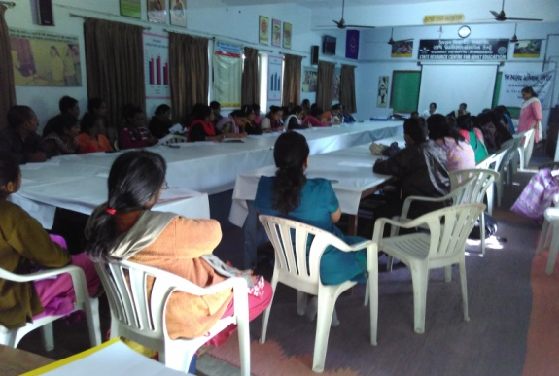
We were very active with JSA during the year. National Human Rights Commission organized public hearing in collaboration with JSA. We had several meetings for necessary preparation. This helped us take OHS issues before larger population. We also had opportunity to make brief presentation in the plenary session.

- At state level JSA meeting on 10 April we made detailed presentation on National Occupational Safety, Health and Environment policy.
- Attended JSA meeting at Ahmadabad on 9 July.
- Attended JSA meeting at Baroda on 21 July.
- Attended State level JSA meeting at Baroda on 17-18 August. One complete session on OHS was organized by us in which OHS problems of agriculture workers, construction workers, brick kiln workers, fish workers were presented by different organizations.
- Attended JSA meeting at Nadiad on 28 September.
- Attended JSA meeting at Ahmadabad on 8 October. Dr.Abhay Shukla of JSA National Coordination Committee attended and discussed about public hearing with NHRC. Important decisions taken.
- Attended JSA Press Conference at Ahmadabad on 19 October. NHRC representative remained present and gave information on the public hearing to be held at Mumbai. He raised issue of silicosis in Gujarat.
- Attended JSA meeting at Ahmadabad on 23 November.
- Attended JSA meeting at Ahmadabad on 11-12 December.
- Attended NHRC-JSA public hearing on right to health care at Mumbai on 5-6-7 January.

Environment and Cancer:

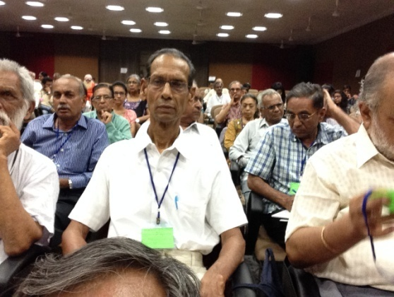
As a result of initiative by Rajani Dave, editor, BHUMIPUTRA, several meetings were held to organize awareness program on Environment and Cancer. Two day program was organized at Gujarat Vidyapeeth, Ahmadabad on 11-12 July. We made presentation on Occupational Cancer in this meeting. We also contributed articles in the collection of articles published on this occasion.

Later one day program was organized in Baroda on 27 December, where again we made presentation on occupational cancer.

Information sought under Right to Information Act:

Number | Date | Information sought from whom | Subject
1 | 07-05-15 | Anand district health officer | Issuance of silicosis certificate
2 | 12-06-15 | Central Ministry of Labor | On enforcement of 2009 National Policy on health ,safety and environment at work
3 | 15-08-15 | Central Ministry of Labor | Filed first appeal as the reply to the RTI in June was not satisfactory.
4 | 01-09-15 | Gems and Jewelry Export Promotion Council | Implementation of project assigned to them by Central Ministry of Commerce to set up common shed for agate workers.
5 | 29-10-15 | Central Ministry of Commerce | To get GJEPC under RTI
6 | 10-03-16 | Director, Ind. Safety & Health, Surat | Information on power loom and textile processing units in Surat
7 | 10-03-16 | Gujarat Pollution Control Board | Pollution by textile units in Surat

Legal Work:

12 complaints filed by us are pending before National Human Rights Commission for disposal. These complaints are for the victims from Khambhat, Jambusar, Dahod and Chhotaudepur. In one of the complaints, the Commission had recommended to pay Rs.5 lakh to each of 5 victim families from Dahod. But Government of Gujarat refused to respect.

We helped 15 victims of silicosis file disability benefit claims before ESI Court against ESI Corporation. Pending hearing 6 of them succumbed and their claims had to be withdrawn. For the remaining 9 Honorable Court passed orders in favor of claimants in February 2015. On 16 June, 2015 we raised claims before the Corporation to enforce the order, when we were informed that Corporation has gone to High Court challenging the order. We contacted Centre for Social Justice requesting them to represent the claimants. Shilpa Shah appears in this matter on behalf of the Centre. Court issued injunction in favor of Corporation for enforcing order of the lower court.

In 2011 we helped Raju Parmar, silicosis victim to file claim under Employees Compensation Act at Anand Labor Court. Raju died same year but the hearing in this claim has continued.

Publications:

- During the year we published 6 issues of SALAMATI. We print 600 copies. 350 copies are sent by post. Rest are distributed free of cost at meetings and gatherings.
- We printed new brochures for the organization this year. Jaydev Babariya designed the brochure without charging any fees. He owns Livana Communications in Ahmadabad.
- Symbol for the organization was designed by Nikhil Mistry without charging any fees. He offered few designs out of which we selected one given here. Nikhil is working for Times of India since long as artist. He had earlier designed book cover for our booklet "Kort ma Karkhanu."
- We published 3ed edition of booklet "Kalmukho Silicosis."
- In May, 2015 we published Guajarati translation of National Policy on Safety, Health and Environment at work, 2009 along with original English.

PTRC in media:

During the year 23 media reports appeared in various different newspapers in which PTRC work reflected:

Number | Date | News paper | Title
1 | 20/4/2015 | Gujarat Samachar | Workshop on safety at work
2 | 3/5/2015 | Divya Bhaskar | Will asbestos be banned?
3 | 3/5/2015 | Times of India | Asbestos link to Over 100 Cancer Cases detected
4 | 3/5/2015 | Indian Express | Environmentalists Seek total ban on import of asbestos
5 | 3/5/2015 | Navgujarat Samay | Workers Sickened due to exposure to asbestos
6 | 4/5/2015 | DNA | NGO Calls for blanket ban on import of asbestos by Center, State govt.
7 | 6/6/2015 | Divya Samachar | Cheque disbursement to the silicosis victim families in Khambhat
8 | 7/6/2015 | Naya Padkar | Cheques given out to the silicosis victim families in Khambhat
9 | 19/6/2015 | Divya Bhaskar | Talk on Occupational Health this Saturday
10 | 20/6/2015 | Divya Bhaskar | Lecture on Occupational Health
11 | 20/6/2015 | Gujarat Samachar | Silicosis victims ultimately get relief. Cheques distributed to the silicosis victim families in Khambhat
12 | 21/6/2015 | Divya Bhaskar | Work shop on the occasion on death anniversary of Viajay Kanhere, pioneer on occupational health in India
13 | 28/6/2015 | Gujarat Samachar | NHRC team visits Khambhat following death due to silicosis.
14 | 28/6/2015 | Gujarat Samachar | With funeral of cancer patient they also burn case history file.
15 | 30/6/2015 | Deep Kamal | Agate units to be visited looking at seriousness of Silicosis
16 | 29/6/2015 | Akila | 150 agate workers die of fatal lung disease.
17 | 13/7/2015 | Gujarat Samachar | 126 chemicals used in beauty products are carcinogens.
18 | 20/10/2015 | Indian Express | NHRC: 5 years on, State Yet to compensate Kin Of 238 Workers
19 | 18/12/15 | Sardar Gurjari | In lack of relief, silicosis patients are in pitiable condition.
20 | 9/12/15 | Divya Bhaskar | No hospital in Waghodia having ESI sanction.
21 | 21/12/15 | Times of India | Silicosis claims two lives in Khambhat
22 | 21/12/15 | Gujarat Samachar | 2 die of silicosis in a day: 20 deaths in 2015.
23 | 21-12-15 | Sandesh | Agate worker families look for monetary relief.
24 | 21-12-15 | Divya Samachar | Two deaths in a day in Khambhat due to silicosis
25 | 22-12-15 | Divya Bhaskar | Two deaths in a day in Khambhat due to silicosis.
26 | 22-12-15 | Sardar Gurjari | Silent disease silicosis kills two more youths in Khambhat.
23 | 15-01-16 | Jagruti | Rs. 37 lakh relief by Gram Kalyan Board
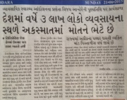
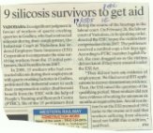
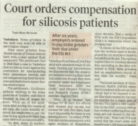

Our Supporters:

- PTRC received Rs.6,66,150/- from University of Toronto, Canada under Grand Challenges project to evolve technology to reduce silica dust in agate processing.
- PTRC received Rs.1,06,421/- for women empowerment project from Asia Monitor Resource Centre, Hong Kong.
- PTRC received Rs.1,57,649/- from Sudwind Institute, Germany for study of textile workers of Surat.
- PTRC received Rs.2,75,647/- donation from individual donors, as listed below.

Number | Name | Amount
1 | Theis Steel Employees Union, Navsari | 05,000
2 | Dr. Jagdish Parikh, Ahmadabad | 20,000
3 | Dr. Yogindra Samant, Mumbai | 07,000
4 | Dr.Vasumati Gokani, Ahmadabad | 05,000
5 | Sri Usmanbhai Abbasi Malek, Shakarpur | 02,100
6 | Sri Dhiru Mistry, Vadodaraâ | 00,300
7 | Sri Jaydevbhai Gokulgandhi, Mumbai | 02,501
8 | Ms.Heenaben Gokulgnadhi,Mumbai | 02,501
9 | Sri Tohidhusen Yusuf Malek, Shakarpur | 02,500
10 | Ms. Mehrajbibi Hamidkhan Pathan,Shakarpur | 03,000
11 | Ms. Fajila Nazirsha Diwan | 03,000
12 | Ms.Rafika Salim Gulam Malek | 02,000
13 | Sri Bhavnesh Vatalia,Vidyanagar | 65,795
14 | M/s. Mit Manpower Solutions, Vadodara | 05,000
15 | Ms.Deepavali Patel,Karamsad | 05,000
16 | Sri Pareshbhai Soni, Khambhat | 01,000
17 | Ms.Mithil Sibhash Samant,Mumbai | 07,000
18 | Sri Joseph Valakuzhi, Kochin | 00,500
19 | Sri Ramesh Patel,Mumbai | 15,000
20 | Sri Vishnubhai Patel,USA | 70,000
21 | Ms.Umaben Desai USA | 32,100
22 | Mr.Thomas Morgan Sommerce, USA | 19,350
 | Total | 2,75,647

Financial Report:

During financial year 2015-16 our income, including interest was Rs.12,81,260/- against which we spent Rs. 11,74,469/-.

Our team:

Our team is small but highly committed. In Baroda office I am assisted by Niranjana Patel who looks after accounts. At Khambhat Jayesh Dave is our coordinator. He is assisted by Naina Vaghela and Ramesh Makwana who are field workers. Manjula Rathod and Bhavna Makwana looks after day care center. Sanjay Ghaghretiya joined us at Baroda office for some time. Since January Roma Bhatt has joined us as part time office assistant.

