Annual Report-2018-19
Executive Summary:
During the year 2018-19 claimants of disability benefits from ESI Corporation were paid the benefits they were entitled to. In 2008 15 tribal victims of silicosis from Dahod district applied for the benefit. When ESIC did not reply they filed petition in ESI Court, Vadodara. During hearing 6 succumbed to Silicosis. In 2015 the court passed order in favor of remaining. ESI Corporation challenged the order in Gujarat High Court. On 20 July High Court upheld the order of the lower court while dismissing the appeal. In the meanwhile one more had succumbed. Ultimately ESIC paid the dues.
A worker in Degam of Jambusar died of silicosis. His widow claimed relief amount from Government. Due to uninterrupted follow up we succeeded in getting the widow paid.
With reference to the complaints filed by PTRC, National Human Rights Commission recommended Government of Gujarat to pay Rs.4 lakh to the families of those died of silicosis. But government of Gujarat was not heeding. In April NHRC organized Public hearing in Gandhinagar in which we were invited to attend. We made representation where GoG representative assure the Commission to enforce the recommendation. Alter GoG paid remaining Rs.3 lakh to those families who were earlier paid Rs.1 lakh.
We worked in Khambhat for several years and we could win some successes which inspired us to expand our work in other areas also. We could initiate our work in Than area from January, 2109 is another achievement.
ILO is celebrating its centenary this year. As part of celebration it came out with collection of 33 think pieces. Jagdish Patel was invited to contribute article on “Difficulties of recording and notification of Accidents and diseases in developing countries.” This can be seen as our contribution in the field of OSH.
ESI Act is an important social security law but its enforcement is poor. PTRC has consistently represented the issues and problems and we can see some outcome. On the other hand we have kept working to raise awareness among workers through training events. You will find in the following pages what did we do.
We have our part of failure, too. We kept working to organize silicosis victims in Khambhat but we could not. We carried out research study of status of textile workers of Surat and then we organized one meeting with the workers to push the work ahead but we could not move ahead as desired.
PTRC is hosting OEHNI Secretariat and we helped members to organize programs. We designed, published and distributed flyer in English and Gujarati on ILO C.155 and distributed among the members. We also published a booklet on Occupational diseases in Gujarati.
We are part of networks like Jan Sawasthya Abhiyan (JSA), Medico Friend Circle (MFC), Asian Ban Asbestos Network (ABAN), Asian Network of rights of occupational and environment victims (ANROEV), Child Rights Collective Gujarat (CRCG) etc. We kept contributing towards the activities of these networks.
We shall keep pressing for the policy for rehabilitation of silicosis victims to be formed by Government of Gujarat as recommended by NHRC.
Publication of newsletter on OSH in Gujarati “SALAMATI” was suspended and later we initiated preparation to continue its publication under new arrangement but we have not succeeded so far. We finished the formalities to fill up form for registration under Registration of Newspapers at local level and sent it to Delhi for further process but we do not hear any communication from that office.
Khambhat:
  - We stopped opening our office in Shakarpur daily. To address the problems we decided to send our field officer once in a week. we continued our efforts to organize the victims so that they themselves can hold the rein of the struggle. But we did not succeed.
  - On 5 April victims were accompanied by Mitesh to MLA who was presented memorandum. Memorandum demanded to get the recommendations of NHRC implemented.
  - National Institute of Occupational Health took up research on diagnosis of silicosis through blood test and sought our cooperation. On 21 April, team of NIOH scientists visited Khambhat. We invited silicosis patients and explained them the purpose of their visit and appealed them to cooperate the team. NIOH team collected blood samples from them for their research.
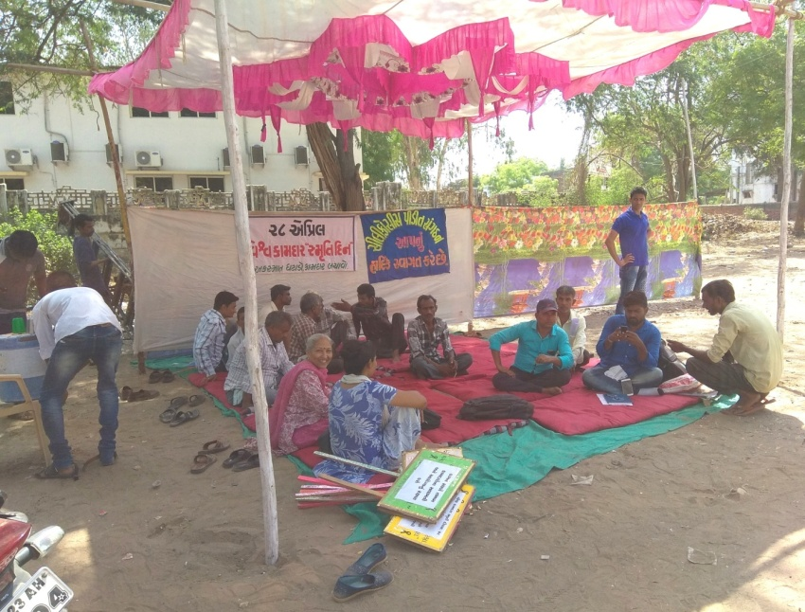
  - International Workers Memorial Day was observed at Khambhat on 28 April 2018. Protests were organized near Ambedkar Statue. It was attended by the victims and their families. Jagdish Patel talked about the importance of the day.
  - In May we took 5 visits. On 11th Memorandum was presented to the Mamlatdar. Rural Labor Commissioner visited Khambhat and invited us for a meeting on 16 May. He was recently appointed and wanted to know about the problem. He seemed serious. He gave some suggestions and direction to his officers with reference to the problems presented.
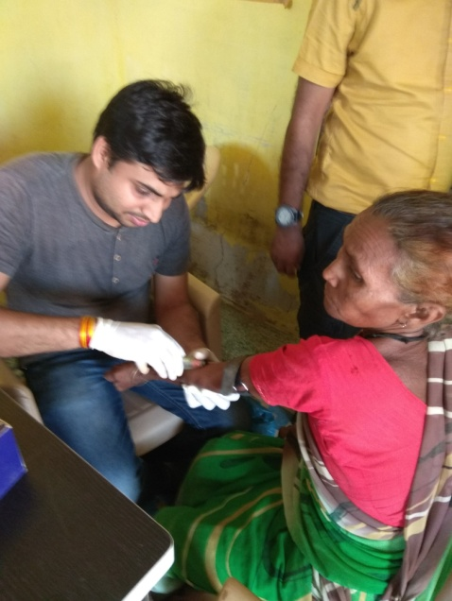
  - In June we took 4 visits. Mitesh visited Government officers and victims and provided guided the claimants
  - Dr.Avinash Pagdhune, NIOH visited Khambhat and looked at the X-rays of the silicosis patients whose blood samples were collected earlier. Later he visited some agate units. On 19 July Mitesh and silicosis victims visited Collector, Anand and represented the problems faced by the victims in claiming relief amount declared by the Government.
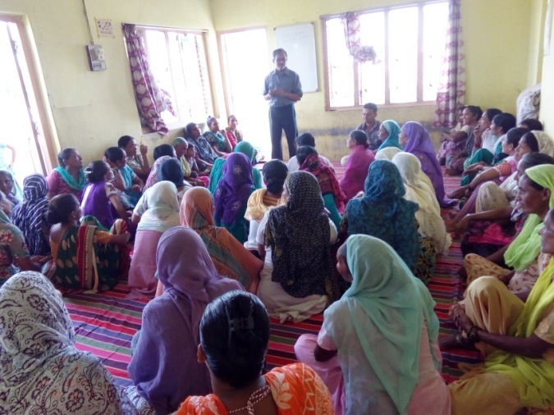
  - 12 visits were taken in August. On August 3 we visited TB Center, Khambhat. On 8 August organized meeting of beneficiaries. ON 28 August Mitesh attended public hearing of coastal zone development authority. He attended program of Jan Vikas and visited Sri Arun Desai, Majur Mahajan in Petlad on 10 September. In October we cooperated during the visit of field workers of Bhansali Trust. In March our visits were with reference to the documentary film to be made on silicosis. We visited silicosis victims Maksud and Sikandar and accompanied Maksud to District TB center in Petlad. Here it was confirmed that he is suffering from Silicosis.
Silicosis:
We regularly attend JSA meetings in which we come across organizations working indifferent geographical areas and different issues. We come to know about the problems faced by the people in different areas. We came to know through representatives of “Sarthi” that some workers engaged in drilling well in their area suffer from TB which may be silicosis. So, we decided to visit the place and meet people. On 11 April Mitesh visited Godhar village and met people suffering from TB. He explained them about silicosis and said that diagnosis is done by X-ray. He suggested them to get the x-rays done. He also requested them to locate other people from the same occupation and suffering from same problem. He suggested them to send their reports to PTRC. We did not receive any reports and we could not organize another meeting with them.
We set up a small committee in Rajkot to think over plan and strategy to work on Silicosis in Than and organized meetings of this committee. Based on the suggestions that we received from members in this meeting Mitesh visited Than on August and met Dinesh Parmar, local trade union leader. He sought his cooperation in organizing a meeting of workers in Than. He agreed but could not organize despite our follow up. Mitesh also met local TB supervisor, Block Health Officer, some patients and other known persons during this visit.
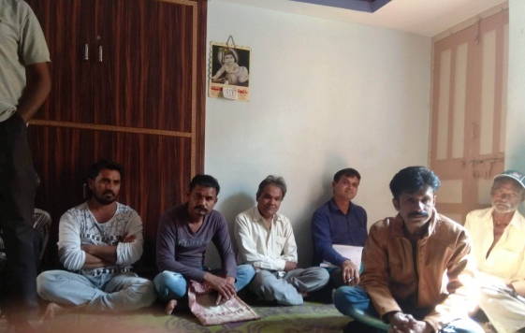
He again visited the area in October when he visited Surendranagar District TB Center and Wankaner TB center. In December we organized meeting with the support group in Rajkot and presented the report. Mitesh visited Than in January and talked to a patient if he can help organize meeting. He agreed and on 5 February we organized meeting at the house of Mukesh Mahalia, himself patient of silicosis. We were accompanied by Himmatbhai Vora of “Ganatar”. 13/14 workers/patients attended the meeting. This meeting assured us that it will be possible for us to work here.
In the meanwhile we stated looking for a fulltime field worker to work in this area. Interviews were organized in Ahmadabad. We selected Nilesh Algotar to work as full timer and Mansukh Olakiya to work as part timer. On March 6 we organized induction training for both of them at “Ganatar” office in Surendranagar.
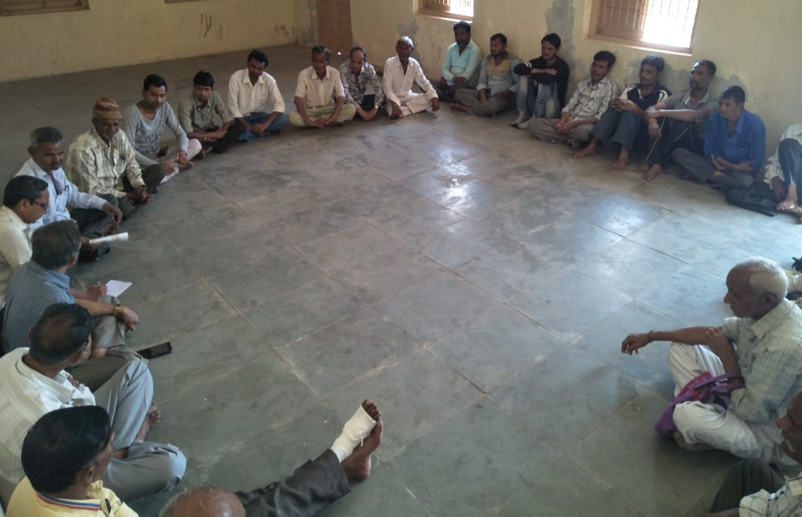
On 14 March meeting was organized in Ambedkar Hall in Than which was attended by 30/40 workers. It was decided in this meeting that there will be meeting every second and fourth Saturday for local volunteers, workers and patients. Later we visited 4-5 patients at their home. On 23 March, being 4th Saturday, meeting was organized in Library Hall in Than. We carried out interviews of patients for documentary film on 22-23 March here.
- On October 16 Mitesh visited Surendranagar TB centre. He also visited Ashok Khatsuria local trade union activist. He then travelled to Wankaner and visited local TB supervisor.
- On 9 December organized meeting of members of Rajkot silicosis group that we formed at the office of the Saurashtra Majur Mahajan Sangh.
- Mitesh visited silicosis victim families in villages in Jhalod in Dahod district in connection with their payment by ESIC on 4 December and again on 23 January.
- Mitesh visited Thangadh on 11 January and met TB supervisor as well silicosis patients in Than.
- Visited Than on 5 February and organized meeting with the group of silicosis patients. On way back visited Sri Mathurbhai in Chotila to seek his support and cooperation for our work on silicosis in that area.
- Provided induction training to the newly recruited staff at GANATAR office in Surendranagar on Silicosis.
- Organized meeting in Ambedkar Hall in Than on Silicosis attended by 40 ceramic workers.
- On 22/23 March Ruturaj Mistry shoot interviews at Than for documentary on Silicosis. Organized meeting with ceramic workers at Library hall in Than on 23 March
- On 27 March visited Ambaji with Dharmendra Gorna to see the mines and workers engaged in stone carving. Visited local leaders.
Legal Work:
On 20 July Gujarat High Court upheld the order by Labor Court, Vadodara ordering ESI Corporation to pay disablement benefit to the 9 claimants. PTRC had helped the claimants file their petition in Labor Court, Vadodara in 2008.
Asbestos:
To get the asbestos banned in India we invited a meeting last year in Delhi in which India Ban Asbestos Network (IBAN) was established and it was decided that its Secretariat would be with Environics Trust in Delhi. IBAN organized meeting in Chennai on 11 May at HMS Hall in Egmore area in Chennai. Jagdish Patel gave a presentation in this meeting.
In Vadodara Industrial Hygienist Utpal Bhavsar has established “Sustainable EHS” is approved agency to provide training for UK based Occupational Hygiene Training
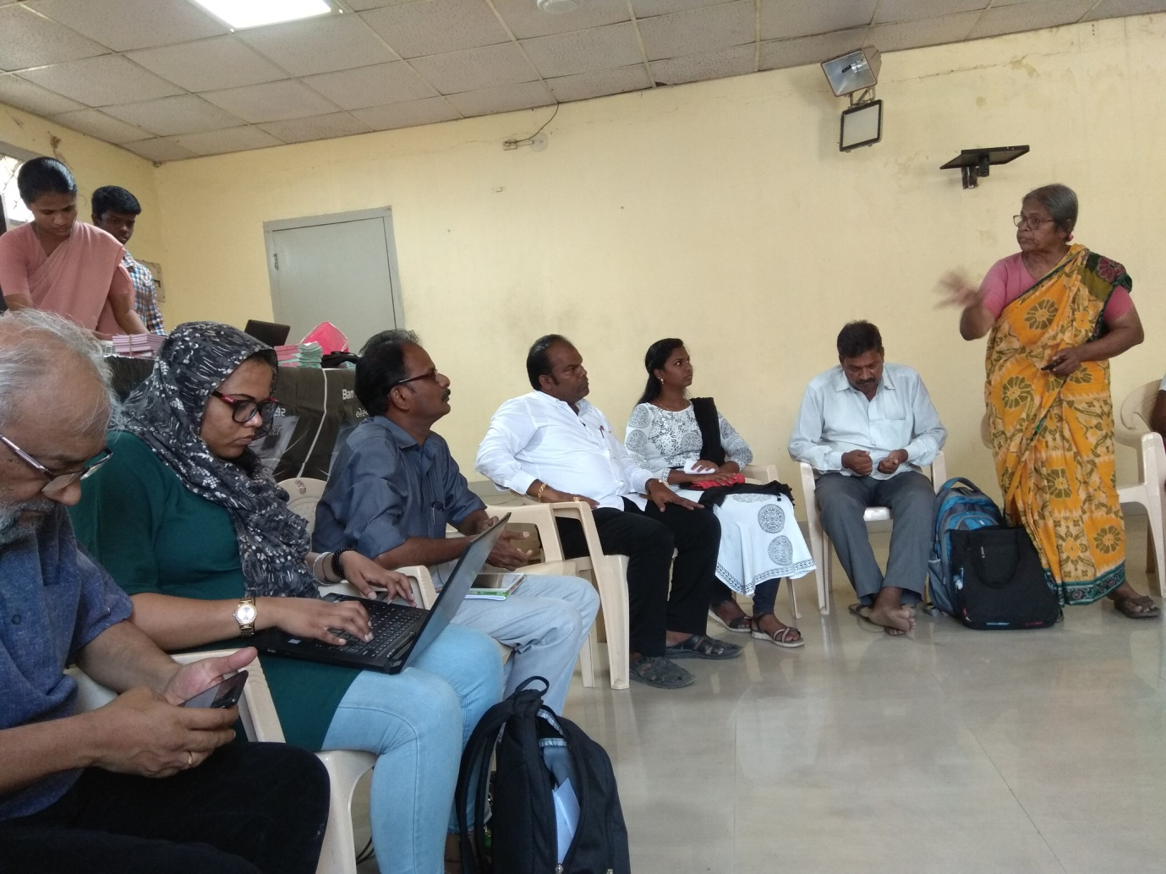
Association (OHTA) to offer British Occupational Hygiene Society (BOHS) recognized training programs. At the end of training exam is conducted. On 28/29 May he organized training for Asbestos in which Jagdish Patel gave a presentation.
Attended meeting organized by IBAN on 19-20 January at Delhi to discuss strategy for next COP meeting of Rotterdam Convention in Geneva.
At a meeting of members of Occupational and Environmental Health Network India (OEHNI) it was decided to organize meeting of asbestos victims in Bhopal. Accordingly OEHNI organized this meeting on 19-20 February which was attended by asbestos victims from Gujarat, Maharashtra and Rajasthan.
RTI Applications:
We registered RTI applications before different authorities during the year as under:
No | Date | Information sought from whom | Content | Note
1 | 22-05-18 | Public Information Officer, Collector Office, Bharuch | Gas leaked from GNFC in November, 2016 in which Collector ordered inquiry. We sought copy of the report. | Collector office transferred application to GNFC; GNFC replied that RTI Act is not applicable to them
2 | 23-07-18 | Appellate Officer, Collector Office, Bharuch | First Appeal on above subject | No reply
3 | 11-09-18 | Gujarat State Information Commissioner, Gandhinagar | Second Appeal on above subject | Application registered on 18-09-18. Later the Commission said that since some documents have not been attached with the petition, it is rejected.
4 | 06-06-18 | Gujarat State Information Commissioner, Gandhinagar | Second appeal for seeking information on accidents occurred while erecting dome for the new ministry to take oath following assembly election
5 | 22-05-18 | Gujarat State Information Commissioner, Gandhinagar | We filed RTI before Rural Labor Commissioner in December 2017. When there was no reply we filed first appeal on 9-03-18 and that too was not replied. So we filed second appeal | Appeal was registered but the Commission ordered that since applicant has not followed the Commission resolution on 30-07-13 to give assurance, application is filed.

Work on ESI:
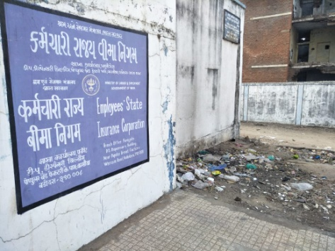
- ESI Corporation has a scheme to open dispensary in collaboration with industry association. Since many complaints come from Waghodiya area it was decided to think over such proposal. In such dispensary State health department does not have any role to play. We talked to the office bearers of Waghodiya Industry Association and they agreed to send proposal to ESIC. Later a meeting was organised between the Association and ESIC on 8 May in the office of the Association. ESIC Sub regional office in Vadodara then sent the proposal to Regional Director for his approval. Till end of the financial year there was no progress.
- On 18 June we visited Warasiya ESI dispensary and local office with the leader of Waghodiya area Mahendra Chauhan and others. We made representation on the problems in July Suvidha Samagam with the pictures.
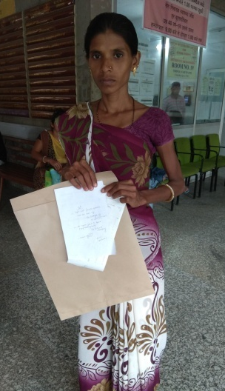
- In July Special Medical Board met at Bapunagar ESI Hospital to examine claims of occupational diseases. Khumsing Fata and Kamila Fata, both victims of silicosis were invited to attend the Board. We accompanied them to the Board to help them and the members of the Board.
- Visited Superintendent of ESI hospital, Vadodara to propose organizing discussion on diagnosis of occupational diseases for the medical officers of the hospital. He advised us to seek permission from the Director of the Scheme.
- On October 1, we visited ESIC Local office in Kalol to inquire on the progress of the implementation of Gujarat High Court order in July earlier.
- We attended monthly grievance redressal meetings called Suvidha Samagam in April, September, October, November, January and March but could not make it in May-June-July-August-December-February.
- On October 1, we visited Kalol ESIC Local Office to know the progress of enforcement of Gujarat High Court passed in July.
- We represented problems faced by individual insured persons (IPs) at monthly grievance redressal meetings called Suvidha Samagam in the months of April, September, October, November, January and March. We could not attend the meetings in May-June-July-August-December and February.
- Visited Regional Director, ESIC, Gujarat Dr. Kala on 29 November at his Ahmadabad office.
- We prepared a press note on whole of Vadodara district being brought under coverage of ESI Act on 25 January.
- We write letters to the State Medical Officer in this period on the complaints.
- We present some case studies and press note that we sent to press which will give some insight on the problems faced by the Insured Persons.

Case Study -1

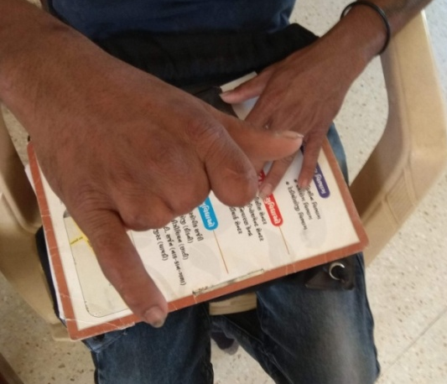
In March end, Mahendra Chauhan, leader of Waghodiya industrial Are visited us with a workers called Sanjay Rohit. He was working under contractor Jagdish (Jaykishor) Sharma in Amar Autotech in GIDC, Waghodiya. On 12-10-16 he met with accident at work while working on press machine and lost 3 fingers of right hand and injured fourth finger. He was not issued ESI card and he did not know anything on the benefits of this Act. After the accident Company sent him to Parul Hospital for treatment and paid the bill. After the treatment he did not resume duty. Someone then advised him to claim compensation. So, through his lawyer he filed compensation claim under ESI Act on 17-02-17. On 21-02-18 the opponent filed their reply in which the company submitted that the unit is covered under ESI Act and the worker was covered under the Act. The Company had submitted the accident form as required by the provisions of the Act already and had presented the copy of the form with the reply. Then the lawyer submitted petition to withdraw the claim which was allowed on 9-03-19 by the Court. After looking at the papers we helped Sanjay to make written representation before the Local officer, Warasiya demanding justice.

Case Study – 2

Jagdish Vankar met with accident at 11.10 PM on 23 January while working in Chopra Industry in GIDC, Waghodiaya. He lost part of his one of the fingers. He was immediately taken to Parul Hospital for primary treatment and was shifted to ESI Hospital, Vadodara next day. His X-ray was taken and then referred to Metro Hospital for plastic surgery and was sent by ambulance at 3.30 AM. At Metro Hospital he was informed that he will not be able to get treatment for next 3-4 days as there are holidays. He went back to ESI hospital by rickshaw and represented. ESIS hospital now referred him to SSG hospital. At SSG Hospital he was asked to register police complaint as this will be a medico legal case and unless it is not done, no treatment shall be given. Though the patients referred by ESI hospital are not required to register police complaint, he was asked to do that. Hearing Police complaint worker got scarred and decided to go home without taking treatment. Next day were informed and we represented the complaint before the RMO of ESI Hospital as well as Asst. Director (Medical Services) ESIS. He was then given permission to seek treatment from Parul Hospital, Waghodiya. He was hospitalized there and his surgery took place on 28-01-19, five days after the accident.

Case Study – 3

In Vadodara region 2.74 lakh workers are covered under ESI Act and 1.75% of their salary is deducted from their salary towards premium or contribution. Employers add additional 4.75% to ESIC. As per ESIC annual report for the period April 2016 to March 2017, ESIC received Rs.13,622.44 crore as contribution and spent Rs.7,776.95 crore on benefits paid to the insured persons and Rs.1732.04 towards administrative expenses totalling Rs.9,727.71 crore. Only during one year they earned Rs.3,934.73 crore. For 50 years they earned profit each year of this level which amounts billions. IN spite of it their hospitals offer only primary and secondary medical care. For tertiary care they have tied up with private hospitals. As a result, bypass surgery and other such surgeries are carried put in private hospitals.

Now, since last few months insured persons and their family members are referred to private tied up hospitals for tertiary care treatment but it is said that ESI Corporation has kept pending crores of rupees bills of these hospitals and therefore these hospitals refuse to give services to the patients referred by ESIS or harass them in different ways.

Dipak Tablawala is insured person under ESI Act. His father was referred to Bankers heart hospital for heart surgery by ESIS hospital in Vadodara in 2017. At Banker’s hospital he was made to pay Rs.14000/- as deposit and was assured that when he submits required documents of permission by ESIS, deposit amount will be returned. He submitted the documents in next 2-3 days but deposit is not returned even after 1.5 years. It is said that hospital bill has not been paid by ESIC and that is the reason deposit is not returned.

It is said that in Surat also bills of private tied up hospitals are pending for payment and IPs are at receiving end as a result. VSS Mandal, made representation by email to the Regional Director, ESIC. Mandal representatives also made representations before Baroda based ADMS, ESIS when he replied that it pains him also and assured that he will make necessary representation before Director ESIS.

PRESS NOTE

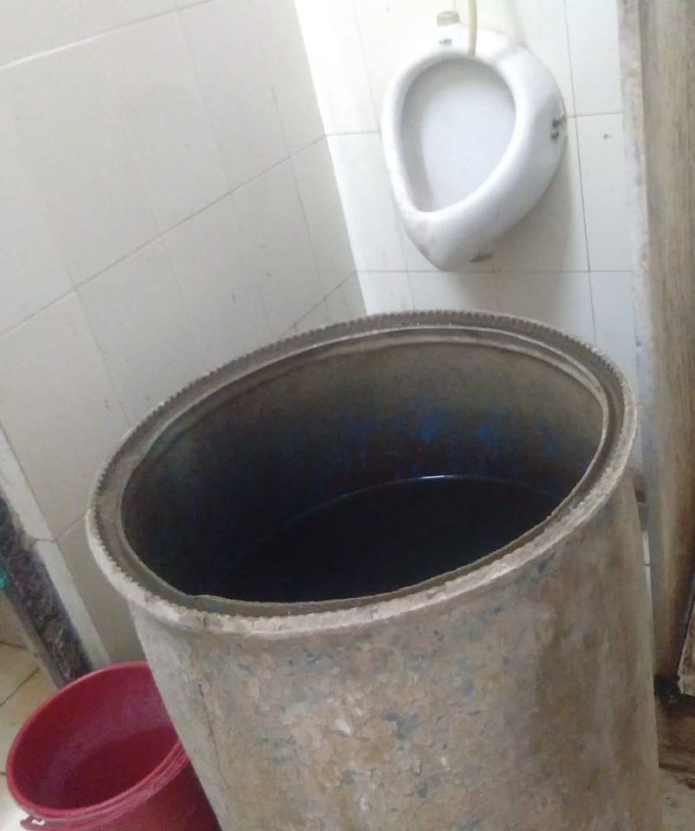
As per the notification issued by ESIC, whole of Vadodara district is brought under the coverage of ESI Act from 20 February. This is huge decision which was pending since long. VSS Mandal welcomes the decision. Accordingly now manufacturing units, shops, cinema houses employing 10 or more workers located on Padra-Jambusar road, Savli-Manjusar, Por Ramangamdi and remaining units in Waghodiya will be covered. from 1 March they will be required to pay their contribution. Employees whose salary is up to Rs.21,000/- will be covered and 1.75% from the salaries of employees and 4.75% of wage bill will be contributed by employers. Estimated 80,000 to 1 lakh new workers will join as IPs. From the first day they will be entitled to get medical benefit but will have to wait till September to get sickness benefit. At present ESI dispensaries in Vadodara are insufficient and they will have to arrange services in new areas soon. It is learnt that ESIC will invite private practitioners to provide medical services. For general practitioners in this area huge opportunity is created. At present there posts of full time orthopaedic and ophthalmologist are vacant at ESIS hospital Baroda and IPs find great difficulties. ESIC has not medical referee and IPs are sent as far as Ankaleshwar. In Wahgodiya area IPs have been demanding to get secondary treatment in their area since long but no one is heeding. Dispensaries need greater attention. Dispensaries in Dandia bazaar, Makarpura gam and Navayard are on first floor where sick, old, pregnant, children find difficult climbing. Warasiya dispensary is itself sick. In surrounding area there is pig colony and very dirty. We have demanded to construct boundary wall but no action is taken. IPs who have undergone IVF are not paid their dues while private hospitals do not return the deposit amount. Money is flowing from workers pockets uninterrupted but services are not improved. This will not go for long. It should be remembered that objective of this law is not just to collect contribution but that of welfare of workers.
Jan Swasthya Abhiyan:
WHO declaration “Health for all by 2000” remained unfulfilled till year 2000. Indian organization working on health with people joined global campaign in response. In India it was named as Jan Swasthy Abhiyan and its chapters were opened in different states. PTRC joined the campaign from those days.
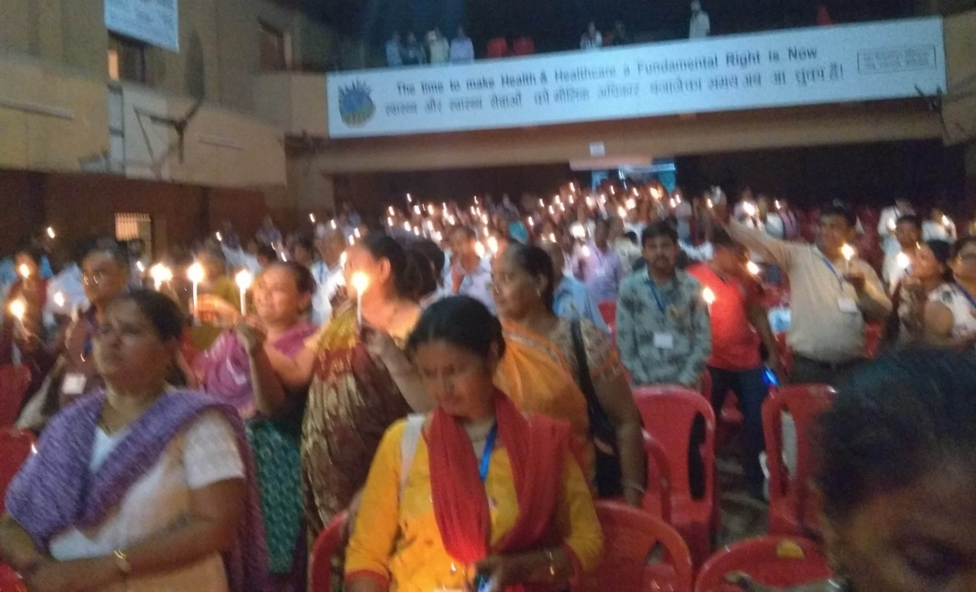
Jagdish Patel is member of steering committee of State JSA. He attended several meetings organized during the year. PTRC participated in research study on 24 X 7 PHCs. 64 participants representing 13 organization from Gujarat participated in National Assembly of JSA met at Raipur on 22-23 September. Jagdish Patel represented PTRC. On 22 September he made presentation in one of the parallel workshops titled “Health harming corporations” during 11.30 am to 1 pm.
Lectures:
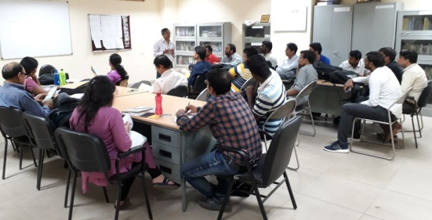
- Senior Citizen Association, Mahemdavad invited us to deliver talk before their members. On 15 April, 2-18 we delivered lecture.
- Gave presentation before students of Ind. Inst. of Public Health, Gandhinagar at Sola Medical college, Ahmadabad on 11 June.
- Gave lecture/presentation on labor laws before Government of Gujarat engineers at Walmi, Gandhinagar on 29 January.
Representation:
- We submitted written representation on our feedback and suggestions on draft labor code on OSH to the Ministry of Labor, Government of India on 22 April, 2018.
- We attended public hearing organized by National Human Rights Commission on 27 April at Police Academy, Gandhinagar and represented on pending issues. We drew the attention of the Commission on the recommendations passed by them in complaints file d by us on silicosis deaths not enforced by the State Government.
- On 4 May, Mitesh visited office of the rural labor commissioner in Gandhinagar to represent case of Ruksanabanu of Jambusar who had applied for relief. Her husband had died of Silicosis and we were helping her claim the relief amount. In this reference he visited Office of the Ind. Safety & Health in Bharuch on 10 May and made written representation to return X-rays which were earlier submitted to them. He also visited GLO (rural) there. Again on 30 July and 24 august he visited ISH office in Bharuch. Certifying Surgeon Dr. Patel informed that the claim has been sent to Gandhinagar for sanction. Mitesh visited Gandhinagar on 29 November in this connection.
- On 24 August Mitesh visited Labor department in Gandhinagar to inquire about minimum wage notifications. He also visited Dy. Secretary, Labor & Employment and discussed various issues faced by workers.
- On 20 December visited Commissioner, Tribal development, Government of Gujarat Sri Ranjeeth Kumar at his Gandhinagar office and presented our note on Resource centre for migrant workers which may be set up at source villages.
- Mitesh visited DISH office and GLO ( Rural) in Anand to follow up cases on 9 January.
Diabetes:
- Sustainable Development Goals include non-communicable diseases. We got opportunity to work on NCDs this year. Mrudula Bhargav studying public health in Israel won Bakken invitation award. Award money can be donated to any voluntary agency suggested by Ms.Bhargav. Ms.Bhargav was interested in working with children suffering from Type 1 Diabetes since she herself is patient. We are also associated with Ek Deesha Foundation who introduced us to Mridula.
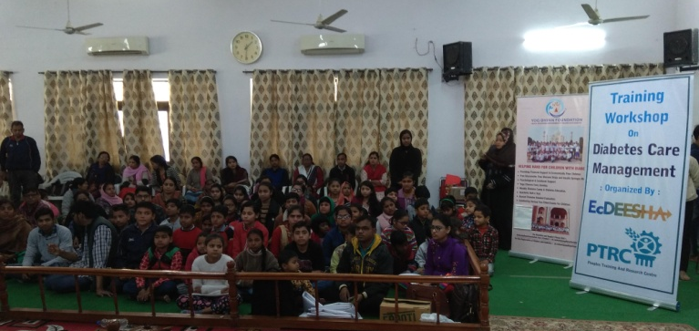
- Ek Deesha Foundation, Tribhuvandas Foundation, Anand and PTRC signed agreement to work on this project.
- On 22 December and 31 December we negotiated with Red Cross Society in Vadodara to work on this project.
- On 17 February we distributed insulin pouches to the children in Delhi.
Attended:
- Attended SAHAJ Meeting on Sustainable Development goals (SDG) on 3 April at Vadodara.
- Attended meeting on Labor code in New Delhi organized by FES on 23 May.
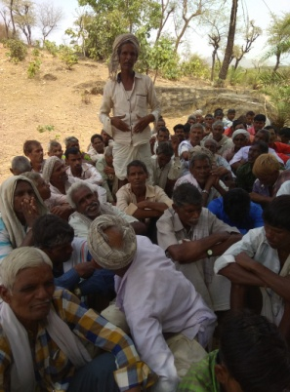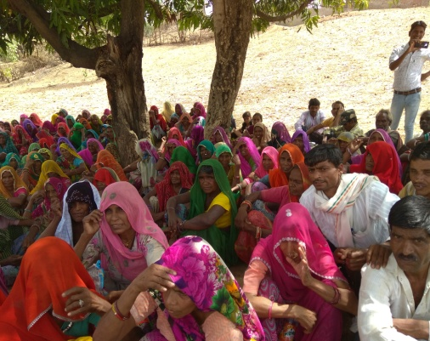

- Attended meeting of past asbestos mine workers in Kankanpur village in Jhadol block of Udaipur district on 31 May.

- Attended Peoples Convention on Asian Development Bank Annual Meeting at Mumbai on 22/23 June. Made presentation.
- Mitesh attended two day state level workshop on nutrition at Gandhinagar on 26/27 June.
- Attended ABAN and ANROEV meetings at Colombo from 9-14 July.
- Attended meeting on Universal health care at New Delhi invited by SEWA on 20/21 August.
- Attended program on problems faced by Migrant Tribal Workers at Ahmadabad on 28/29 September. Participated in discussion and gave suggestions.
- Attended meeting on Occupational Safety & Health at Erode on 6/7/8 October and gave presentation.
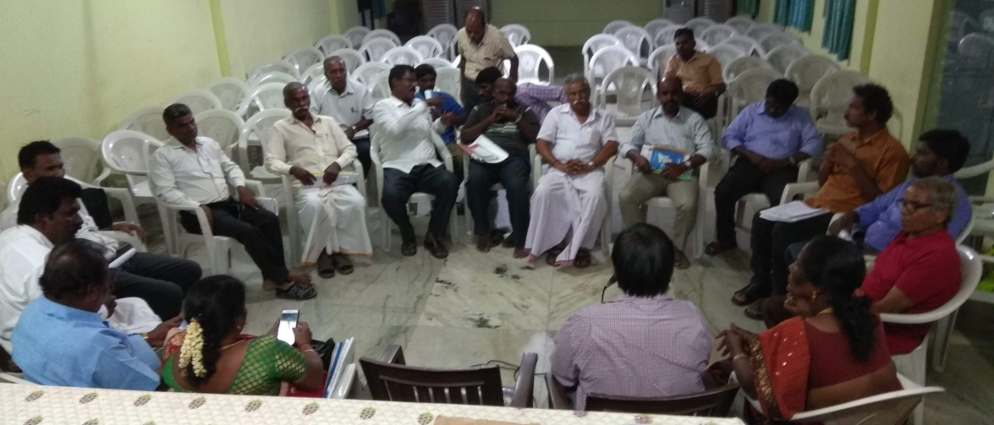
- Attended program organized by Bandhkam Mazdur Sangathan at Ahmadabad on 15 December.
- Attended follow up meeting on the problems of tribal migrant workers at Ahmadabad on 20 December.
- Attended workshop on silicosis at Delhi as part of International Conference on Occ. and Env. Health on 13/14/15 February.
- Attended workshop on Advancing Environmental Health Science Research and Translation in India through Community Based Participatory Research organized jointly by PRIA and University Iowa College of Public health (USA) at Delhi on 26-28 February.
- Participated in discussion organized by The American Centre at New Delhi on 28 February on Environmental health and actionable research as panel member.
- Attended meeting organized by AAJEEVIKA Bureau at Surat on 16 March to present report of their work on noise induced deafness among power loom workers in Surat.
Visited:
- Visited Sri Bipin Shroff and Urvish Kothari at Mahendavad on 15 April.
- On 16 June visited Un near Surat with Vipul Pandya to have initial discussion to organize meeting with textile workers.
- Visited Director, NIOH on 22 August to seek his permission for NIOH visit by delegates of OEHNI during forthcoming members meeting. He gave his consent.
- Visited Bhavanagar to see the work being carried out by women workers, members of SEWA. They work in plastic reprocessing as well electronic waste on 23 October.
- Visited Dr. Karuna at The Union in Delhi to discuss issues of misdiagnosis of TB on 1 March
- On 27 March visited mines and stone carving units in Ambaji and met with local leaders.
Guests:
- Sri K.U.Mistry, Ex Chairman, GPCB visited us on 7 April, 2018
- Narendra Shastri from Khambhat visited us on 4 May, 2018.
- On 15 October Yohana Lokhande and Binita Modi of IPROBONO visited us.
- Satoshi Miyamura research scholar working with Oriental and African Studies, Uni. of London visited us on 11 February.
Organized training/Meeting:
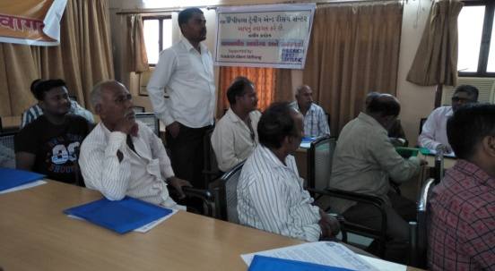
- Organized meeting with textile workers of Surat at UN on 24 June.
- on 30 June organized training on ESI at for workers of Waghodiya industrial area. Venue was Training Hall of Munjal Auto. It was attended by – participants.
- On 4 July organized training of Foundry workers at Rajkot.
- On 13 August organized meeting with NGOs working on asbestos in Rajasthan, activists and past asbestos mine workers at Udaipur. Drew plans on how to work to identify exposed population.
- Organized follow up meeting with foundry workers in Rajkot on 23 August.
- Organized trainings of construction workers with Bandhkam Mazdur Sangathan at Junagadh on 24 August and in Veraval on 25 August.
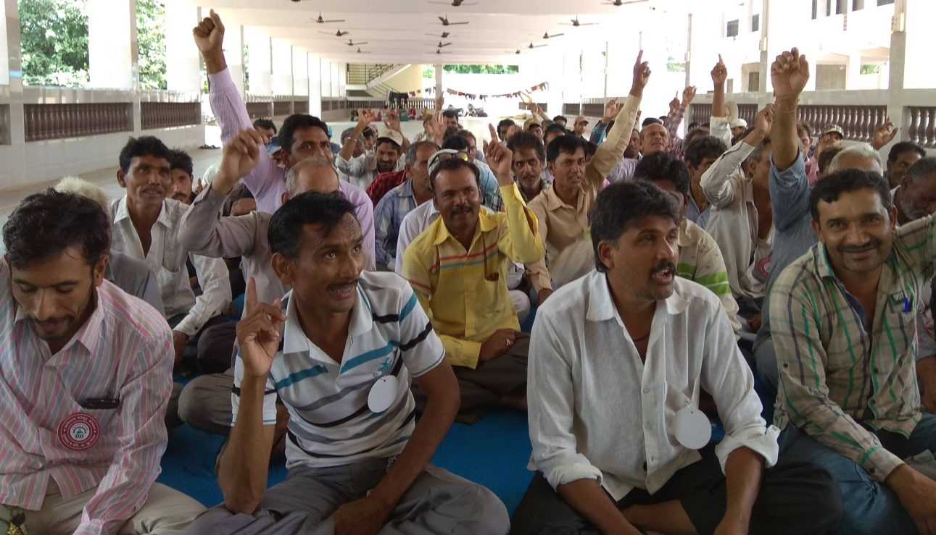
- On 17 August organized meeting of silicosis advisory group at Rajkot.
- Organized OEHNI members meeting at Ahmadabad on 27/28 September. Members visited NIOH on 28 September.
- Organized training on ESI at Halol for the workers of Halol industrial area on 26 November.
- Imparted training to the women workers of Bhavnagar engaged in waste recycling of Alang waste on 5-6-7 December.
- Organized training of ST workers on OSH at Rajkot on 9 December.
- Organized meeting jointly with Bandhkam Mazdur Sangathan at Ahmadabad on 3 January on proposed Labor codes.
- Organized OSH training for Alang Ship breaking yard at Alang on 6 January, 2019.
- On 16 January organized meeting on Asbestos on Delhi.
Proposals:
- Yes Foundation invited proposals in the form of 3 minute video. With the help of Ruturaj Mistry we prepared 2 proposals we submitted these two 3 minute videos to Yes Foundation. Our both films passed through first screening and we were invited to fill up forms. We submitted the forms on 18 May. Unfortunately our proposals were not accepted in final run.
- PTRC proposed Director, ESIS to organized discussion on diagnosis of occupational diseases in ESI Hospital, Vadodara for the medical officers of the hospital.
Electronic Media:
On 11 April and again on 16 April we participated in discussion on ESI on GTPL News Channel where we discussed problems of ESI.
PTRC in News:
No | Date | Name of the newspaper | Title | Note
1 | 15-04-18 | Nav Gujarat Samay | There are several working for justice to the 15 million unorganized sector workers and need more | Column “Samudra Manthan” by Dr.Vidyut Joshi
2 | 29-04-18 | Divya Bhaskar | International Workers Memorial Day observed in Khambhat
3 | 30-04-18 | Sandesh | Protest by Silicosis victims in Khambhat
4 | 30-04-18 | Sandesh | Demand before NHRC to help silicosis victims who die in absence of help
5 | 04-05-18 | Nav Gujarat Samay | Story of the helpless Gujarat workers getting fatal silicosis while cutting stones | Column :Kshitij” by Sanjay Bhave
6 | 14-07-18 | Gujarat Guardian | Everything changed not exploitation of workers | Column “Vistarti Kshitijo” by Suryakant Shah
7 | 21-07-18 | Counterview | Silicosis: Gujarat High Court asks Employees State Insurance Corporation to pay compensation to nine victims of deadly disease.
8 | 22-07-18 | Sandesh | Order in favour of silicosis victims: ESIC is adding pain of the workers- High Court slams
9 | 22-07-18 | Indian Express | High Court dismisses ESI petitions challenging compensation
10 | 22-07-18 | Times Of India | High Court uphold compensation for workers suffering from silicosis
11 | 27-07-18 | BBC Gujarati | Pain of Women workers in Gujarat: Not allowed break for wash room
12 | 18-07-18 | Naya Padkar | Agreement between Ekdeesha Foundation, PTRC and Tribhuvandas Foundation to work on diabetes.
13 | 17-03-19 | Counterview | ESIS to enrol private practitioners as it expands to Vadodara District: Benefit 80,000 workers
14 | 17-03-19 | Counterview | Demand from Gujarat Government to support Silicosis patients continually on Oxygen
15 | 18-03-19 | Sandesh | Whole of Vadodra district covered under ESI Act
16 | 26-03-19 | Indian Express | NHRC notice to Gujarat Government for failing to protect Agate workers

Our supporters:
- OK International, USA gave Rs.48,567/- for work on TB/Silicosis.
- Asia Monitor Resource Centre, Hong Kong gave Rs.7,40,920/- for work on OHS and networking.
- Asia Monitor Resource Centre, Hong Kong gave Rs.19,200/- for work on asbestos.
- FES, Delhi gave Rs.29,960/- for trainings.
- Charities Aid Foundation of America gave Rs.13,46,881/- for work on diabetes
- Received Rs.3,36,502/- from individual donors as under:

NO. | Name | Amount
1 | Subhash Soka Damor | 0,30,000
2 | Dr.Jagdish Parikh | 0,20,000
3 | Menaben Nandubhai | 0,30,000
4 | Jaydevbhai Gokulgandhi | 0,02,501
5 | Heenaben Gokulgandhi | 0,02,501
6 | Vasumatiben Gokani | 0,05,000
7 | Khumsing Fatabhai Kamol | 0,30,000
8 | Lasing Sadia Garasiya | 0,30,000
9 | Dhiru Mistry | 0,05,600
10 | SEWA Rural | 0,00,400
11 | Ramesh K.Patel | 0,30,000
12 | Kamila Fata Kamol | 0,30,000
13 | Bhartiben Ganpatsinh | 0,10,000
14 | Atul Padia | 0,24,500
15 | Rajubhai Solanki | 0,05,000
16 | Dyes & Chemical Workers Union | 0,00,500
17 | Gujarat Rajya Sahkari Mandli Karmachari Sangh | 0,00,500
18 | Ms.Mithil Subhash Samant | 0,06,000
19 | Ramesh B.Patel | 0,74,000
 | Total | 3,36,502

Financial report:
During the financial year 2018-19 our income, including interest was Rs.26, 02,036/- against which we spent Rs.18,24,842.86 on the objectives of the organization.
Our team:
During the year I was assisted by Niranajana Patel for keeping accounts and Mitesh Mahida for field work. For Than Nilesh Algotar joined us in March and by the end of the month he secured Government job and left. Diabetes project was looked after by Mridula Bhargav and Pallavi Gupta.

